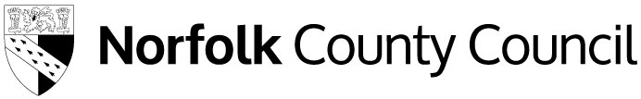

Free School Meals application

Applying online
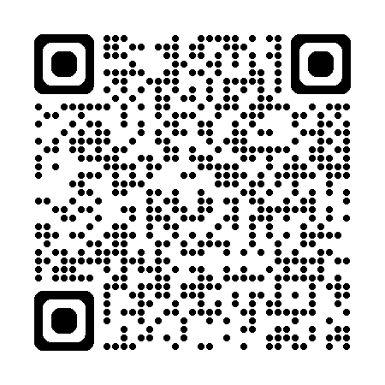
www.norfolk.gov.uk/freeschoolmeals
The easiest and quickest way to apply is online via Norfolk Education Online (NEO).
Scan the code or visit the link and click ‘Apply for free school meals’.

Introduction
Dear parent or guardian,

We want to make sure that we are providing your child with the best education and support we can. Healthy school food can help pupils establish healthy habits for life and help improve pupils’ readiness to learn. You may qualify for Free School Meals (FSM) and other help if you receive certain benefits or support. There are two types of entitlement:

- Targeted: you receive Universal Credit and earn under £7,400 a year or another qualifying benefit: your children are entitled to FSM and extra support for their school
- Expanded: you receive Universal Credit and earn above £7,400: your children are entitled to FSM only

All children attending Reception, Year 1 and Year 2 automatically receive Universal Infant Free School Meals (UIFSM). If you think you might be eligible for FSM, you should still apply as you may be able to help your child’s school get extra funding.

If your children attend different schools, apply separately to each. You do not need to reapply, as we will recheck eligibility before the start of each school year. If your child moves or your situation changes, contact us or the school.

The information collected in this form allows us to assess your eligibility. We are committed to ensuring that the personal and sensitive information that we hold about you is protected and kept safe and secure, and we have measures in place to prevent the loss, misuse or alteration of your personal information. The information may also be shared with other County Council departments to offer benefits and services.

Please complete all sections on the next page in block capitals.

Parent or guardian details
 | Parent or guardian 1 | Parent or guardian 2
Last name
First name
Date of birth
(DD/MM/YY)
National Insurance number
Asylum support reference number
Telephone
Mobile number
Email address
Address | Postcode: | Postcode:

About your child or children
Child’s last name | Child’s first name | Child’s date of birth (DD/MM/YY) | Name of school

Declaration
By signing below, I confirm that I allow the use of the data in this form for the purpose of checking whether my children are entitled to FSM, including future annual rechecks. I allow the sharing of the above data with the schools my children attend and within County Council departments to help offer any other benefits and services.

Signature Date (DD/MM/YYYY)

Submission
Submit your form by email to fsm@norfolk.gov.uk, to your school or by post to: Free School Meals, Norfolk County Council, County Hall, Norwich, NR1 2DH

