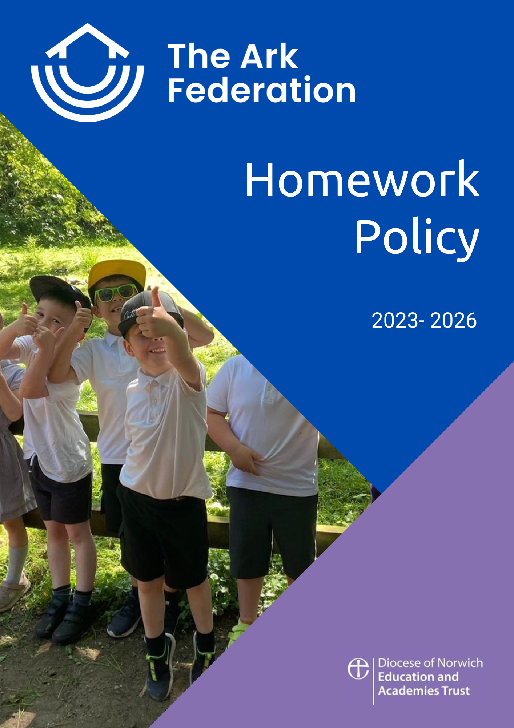

Introduction

We believe that learning is a life-long process and not something that is limited to the classroom or school building. Developing a culture of continuous learning is an invaluable life skill as well as being part of a good education.
However, we also recognise that every family is different and that all households have their own unique set of circumstances. We understand that sometimes adults are unable to help children with their work due to work commitments or personal circumstances.

Definition

“Homework” is any work or activity completed outside lesson time, either alone, with parents, or others. This can include activities such as reading, learning spellings or completing written or practical activities.

Aims

We see the purpose of homework as being to:
- Develop an effective partnership between school and parents for each child’s education, as children achieve more when teachers and parents work together,
- Consolidate/reinforce skills and understanding, particularly in Literacy and Numeracy,
- Develop confidence, independence and the self-discipline needed for personal study in preparation for secondary school and life-long learning,
- Provide opportunities for parents and children to work together to enjoy learning experiences

Homework Allocation and Expectations

Every child will have access to a basic and an extended homework offer.
The basic offer will provide weekly work for every child to do at home, covering the core skills needed to consolidate their classroom learning. The extended offer will give children the opportunity to spend more time consolidating their understanding of the wider curriculum.

We understand that all households have their own personal circumstances and that regular homework can be difficult for some children. Therefore, all homework is optional and parents can decide how much and how frequently it is completed.

The purpose of homework is to create a culture of life-long learning, where you learn for enjoyment and the feeling of fulfilment that new knowledge can bring. Therefore, we will not give any reward for completing homework and there will be no sanction when it is not completed.

Basic Offer

Year Group | Activities
Foundation  Stage | Daily reading to parents and listening to stories  Number and counting activities  Phonics reinforcement work
Year 1 and Year 2 | Daily reading to parents and listening to stories  Spellings / sounds  1 piece of Maths or English work linked to classroom learning
Years 3 and Year 4 | Daily reading to parents and/or Independent reading  Spellings  Tables / Number facts  1 piece of Maths or English work linked to classroom learning
Years 5 and Year 6 | Daily reading to parents and/or Independent reading  Spellings  Tables / Number facts  1 piece of Maths or English work linked to classroom learning (this may increase in preparation for high school)

Extended Offer

Each term every year group will upload an Extended Offer document onto the school website. The document will list a number of activities that children could complete at home (independently or with parents) linked to the wider curriculum topics that will be covered in class.

Differentiation

There is an expectation that the work that is sent home will consolidate the work completed in class. This will mean that homework needs to be differentiated at times. Children should not be taking home work that they cannot complete.

Marking / Feedback

Teachers are expected to collect in and look through any completed homework. However, there is no expectation that written marking or feedback is given. Where families or children raise concerns about homework being too easy or difficult, teachers will work with the child and offer appropriate support.

